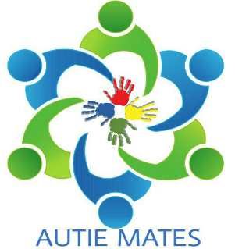
Autistic Adult’s Social Groups
What are we? We are a small charity in partnership with Little Treasures Autism Charity. We were established as a peer support network in 2017 and had groups in and around County Durham and Tyne and Wear. We can be accessed via email at Autiemates@gmail.com, telephone on 07562284485 or Via Facebook, search for @autiemates. No referrals needed, just come along!
What we do: Autie Mates are social groups that provide safe places for autistic adults to meet other autistic individuals. These groups aim to help improve your wellbeing and irradicate isolation within the autistic community. They give autistic adults a chance to share their interests and experiences in a friendly and non-judgemental environment.
Our Groups: Each group is facilitated by an autistic adult, and we promote positivity within our groups. Our groups cost £2 per session, money which goes towards room hire. What is available at the groups:
- Tea/coffee
- Sweet Treats
- Board Games
- Art Supplies
- Mindfulness Colouring
- One to Ones with our volunteers
- Friendship Building
- Volunteer Opportunities
Who Attends: Autistic adults 18 or over, a plus one is allowed for support if needed. The group is suitable for autistic individuals that are able to verbally communicate. It may not be suitable for those with Learning Disabilities.
